[ Your Logo Here ]
[Insert your Kabuto brand name here, example: Tech Watcher]
Better protect your computer.
Thanks for choosing our company for your computer service needs. As part of the service, we installed a free program called [ Your Product Name ] that will alert you to any issues that may arise. [ Your Product Name ] also allows you to quickly get in touch with us when needed.

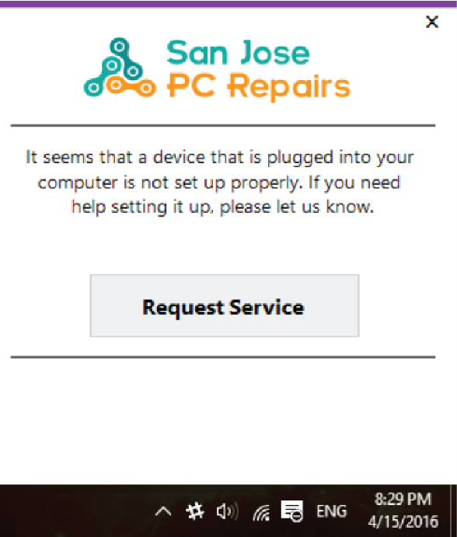  Here is an example of an alert. | Proactive Alerts  If [ Your Product Name ] finds an issue, it will notify you so you can contact us for service.  Quickly Request Assistance  To immediately contact us for help, click Request Service and enter your contact information.  We’ll get in touch with you to discuss the best solution.

Learn More About our Comprehensive Protection Plans:

Monitoring  - Proactive monitoring and service communication  $4.99/month | Managed  Anti-Virus  - Proactive monitoring and service communication  - Virus monitoring and removal  $14.99/month | Managed  Plus+  - Proactive monitoring and service communication  - Virus monitoring and removal  - PLUS – free computer clean up if you come in  $29.99/month

